Inventory Management and Stock Tracking System
Project Made By
Afifah Khatoon

Objective
The objective of this project is to efficiently manage inventory records and track stock movement within the organization. This system helps monitor stock availability, stock check-in, and stock check-out processes while maintaining accurate inventory data for better decision-making.

Tools Used
- Microsoft Excel
- Pivot Table
- Pivot Chart
- Dashboard
- Excel Formulas & Functions
- Data Cleaning & Formatting

Project Description
- Data Cleaning
- Data Formatting
- Inventory Tracking
- Stock In & Stock Out Management
- Available Stock Calculation
- Dashboard Creation
- Pivot Table Analysis

Dashboard Features
- Total Available Stock
- Total Stock In
- Total Stock Out
- Product-wise Analysis
- Category-wise Inventory Report
- Monthly Stock Movement Summary

Raw Dataset:-
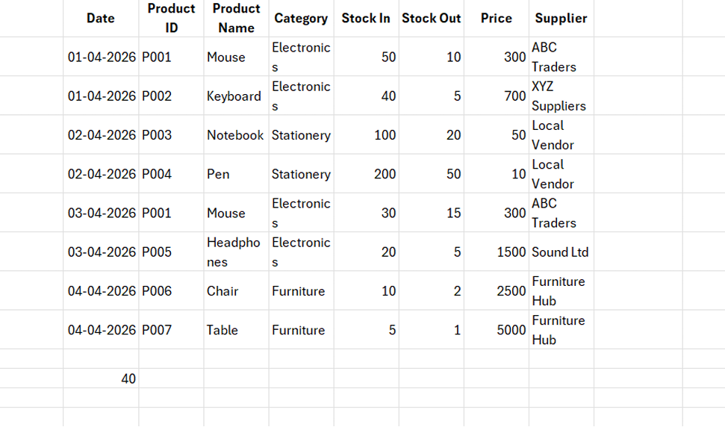
Inventory Stock Analysis Report:-
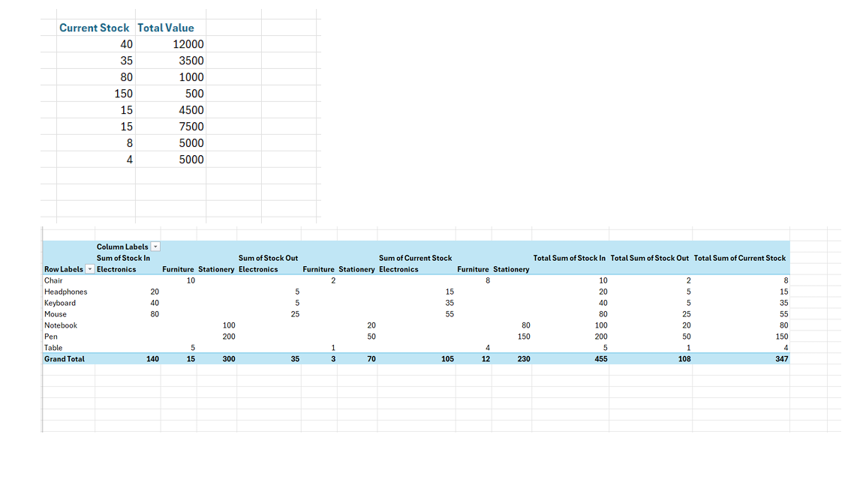
Stock In, Stock Out & Current Stock Dashboard :-
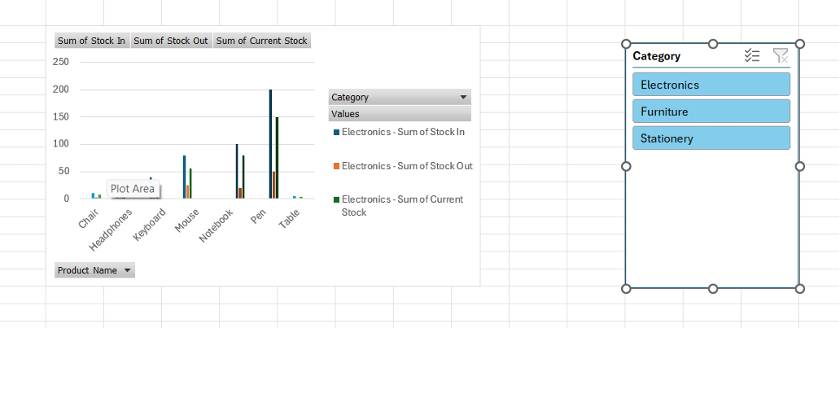

Conclusion:-
This project improved understanding of inventory management and stock tracking processes using Microsoft Excel. The dashboard provides a clear and organized view of inventory activities, helping in better stock control and data analysis.

Thank You,

